FOR IMMEDIATE RELEASE CONTACT
October 17, 2022 Laura Anderson
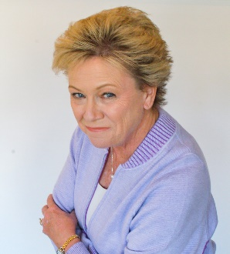
630.267.7119

NATIONAL ANCOR RECOGNIZES KATHY CARMODY FOR HER LEADERSHIP
CEO OF ILLINOIS’ INSTITUTE ON PUBLIC POLICY FOR PEOPLE WITH DISABILITIES

Chicago, IL – Kathy Carmody, CEO of the Institute on Public Policy for People with Disabilities was recognized with a national award from ANCOR, the leading voice in Washington for providers of community-based services that empower people with intellectual and developmental disabilities (I/DD) to live and work in the community.

The recipient of the 2022 Diane McComb State Association Star Award is Kathy Carmody, chief executive officer of the Illinois-based Institute on Public Policy for People with Disabilities. Named for a long-time disability services professional known for her work to cultivate a national network of statewide disability service provider associations, the Diane McComb State Association Star Award recognizes the role of a state provider association leader in transforming the delivery of I/DD services.

“I am honored and humbled to receive the Diane McComb State Association Star Award from ANCOR at their national policy conference this week. Diane's commitment and leadership in the state association community is legendary and to be recognized as following in her footsteps is truly an honor” Kathy responded. “Our membership with ANCOR has been an invaluable asset to the Institute and our member organizations; we are so thankful to be partners with ANCOR. I am so appreciative to serve as CEO of the Institute and for the opportunity to represent Institute member organizations at both the state and national levels,” Kathy shared.

“As the CEO of the Institute for Public Policy for People with Disabilities for nearly eight years, Kathy Carmody has coalesced the leaders of more than 52 organizations to focus on making marked improvement for the Illinois IDD system. Her ability to identify the key drivers of quality service and harness the collective influence of providers to impact state policy is unparalleled in the field,” stated Mark McHugh, Chair of The Institute and CEO of Envision Unlimited.
Members of the Institute shared their thoughts about the honor. “Kathy receiving the Diane McComb State Association Star award is so awesome and well deserved! We are incredibly lucky to have her as the Institute’s CEO,” said Gerald Beagles, CEO, Garden Center Services.
“Kathy receiving this award is well deserved for her dedication to the field and continuous support of all the providers in Illinois! Park Lawn is happy to be a member organization of the Institute,” Frank M. Portada, Executive Director, Park Lawn Association.
ANCOR presented their 2022 Excellence in Public Policy Awards at their annual ceremony in Washington, D.C., on October 11, at the association’s 2022 Policy Summit & Hill Day.

# # #

The Institute on Public Policy for People with Disabilities is a private sector non-profit organization focused exclusively on disability policy issues in Illinois. For over 2 decades, the Institute has been a trusted resource on issues and proposals impacting people with intellectual and developmental disabilities in Illinois. Our national perspective and statewide experience and exposure position the Institute as an insightful, innovative and respected voice in the Illinois disability policy arena.

